**DEEP LEARNING**

**Introduction:**

Deep learning is a machine learning technique that teaches computers to do what comes naturally to humans: learn by example. Deep learning is a key technology behind driverless cars, enabling them to recognize a stop sign, or to distinguish a pedestrian from a lamppost. It is the key to voice control in consumer devices like phones, tablets, TVs, and hands-free speakers. Deep learning is getting lots of attention lately and for good reason. It’s achieving results that were not possible before.

In deep learning, a computer model learns to perform classification tasks directly from images, text, or sound. Deep learning models can achieve state-of-the-art accuracy, sometimes exceeding human-level performance. Models are trained by using a large set of labeled data and neural network architectures that contain many layers.

**History Of Deep Learning:**

The history of Deep Learning can be traced back to 1943, when Walter Pitts and Warren McCulloch created a computer model based on the neural networks of the human brain. They used a combination of algorithms and mathematics they called “threshold logic” to mimic the thought process. Since that time, Deep Learning has evolved steadily.

The earliest efforts in developing Deep Learning algorithms came from Alexey Grigoryevich Ivakhnenko (developed the Group Method of Data Handling) and Valentin Grigorʹevich Lapa (author of Cybernetics and Forecasting Techniques) in 1965. They used models with polynomial (complicated equations) activation functions, that were then analyzed statistically. From each layer, the best statistically chosen features were then forwarded on to the next layer (a slow, manual process).

The first “convolutional neural networks” were used by Kunihiko Fukushima. Fukushima designed neural networks with multiple pooling and convolutional layers. In 1979, he developed an artificial neural network, called Neocognitron, which used a hierarchical, multilayered design. This design allowed the computer the “learn” to recognize visual patterns.

**Why Deep Learning Matters?**

Deep learning achieves recognition accuracy at higher levels than ever before. This helps consumer electronics meet user expectations, and it is crucial for safety-critical applications like driverless cars. Recent advances in deep learning have improved to the point where deep learning outperforms humans in some tasks like classifying objects in images.

While deep learning was first theorized in the 1980s, there are two main reasons it has only recently become useful:

1. Deep learning requires large amounts of  **labeled data**. For example, driverless car development requires millions of images and thousands of hours of video.
2. Deep learning requires substantial **computing power**. High-performance GPUs have a parallel architecture that is efficient for deep learning. When combined with clusters or cloud computing, this enables development teams to reduce training time for a deep learning network from weeks to hours or less.

**How Deep Learning Works??**

Most deep learning methods use [**neural network**](https://in.mathworks.com/discovery/neural-network.html) architectures, which is why deep learning models are often referred to as **deep neural networks**.

The term “deep” usually refers to the number of hidden layers in the neural network. [Traditional neural networks](https://in.mathworks.com/videos/getting-started-with-neural-networks-using-matlab-1591081815576.html) only contain 2-3 hidden layers, while deep networks can have as many as 150.

Deep learning models are trained by using large sets of labeled data and neural network architectures that learn features directly from the data without the need for manual feature extraction.

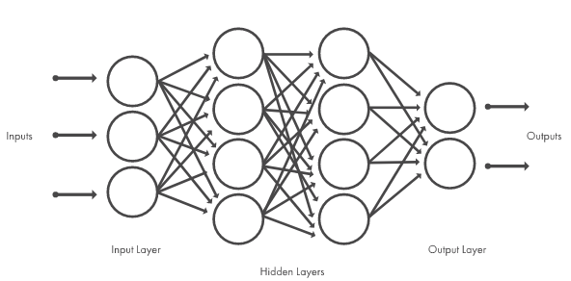

One of the most popular types of deep neural networks is known as [convolutional neural networks](https://in.mathworks.com/solutions/deep-learning/convolutional-neural-network.html)**(CNN** or**ConvNet)**. A CNN convolves learned features with input data, and uses 2D convolutional layers, making this architecture well suited to processing 2D data, such as images.

CNNs eliminate the need for manual [feature extraction](https://in.mathworks.com/discovery/feature-extraction.html), so you do not need to identify features used to classify images. The CNN works by extracting features directly from images. The relevant features are not pretrained; they are learned while the network trains on a collection of images. This automated feature extraction makes deep learning models highly accurate for computer vision tasks such as object classification.

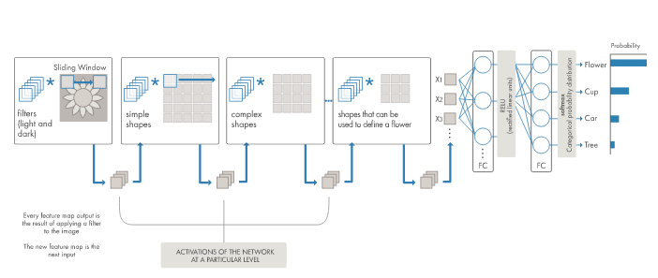

**How to Create and Train Deep Learning Models**

The three most common ways people use deep learning to perform object classification are:

1. **Training from Scratch:-** To train a deep network from scratch, you gather a very large labeled data set and design a network architecture that will learn the features and model. This is good for new applications, or applications that will have a large number of output categories. This is a less common approach because with the large amount of data and rate of learning, these networks typically take days or weeks to train
2. **Transfer Learning:-** Most deep learning applications use the [transfer learning](https://in.mathworks.com/discovery/transfer-learning.html) approach, a process that involves fine-tuning a pretrained model. You start with an existing network, such as AlexNet or GoogLeNet, and feed in new data containing previously unknown classes. After making some tweaks to the network, you can now perform a new task, such as categorizing only dogs or cats instead of 1000 different objects. This also has the advantage of needing much less data (processing thousands of images, rather than millions), so computation time drops to minutes or hours.
3. **Feature Extraction:-** A slightly less common, more specialized approach to deep learning is to use the network as a **feature extractor**. Since all the layers are tasked with learning certain features from images, we can pull these features out of the network at any time during the training process. These features can then be used as input to a [machine learning model](https://in.mathworks.com/solutions/machine-learning.html) such as [support vector machines (SVM)](https://in.mathworks.com/discovery/support-vector-machine.html).

**Applications Of Deep Learning**

Deep learning applications are used in industries from automated driving to medical devices.

* Automated Driving: Automotive researchers are using deep learning to automatically detect objects such as stop signs and traffic lights. In addition, deep learning is used to detect pedestrians, which helps decrease accidents.
* Aerospace and Defense: Deep learning is used to identify objects from satellites that locate areas of interest, and identify safe or unsafe zones for troops.
* Medical Research: Cancer researchers are using deep learning to automatically detect cancer cells. Teams at UCLA built an advanced microscope that yields a high-dimensional data set used to train a deep learning application to accurately identify cancer cells.
* Industrial Automation: Deep learning is helping to improve worker safety around heavy machinery by automatically detecting when people or objects are within an unsafe distance of machines.

**What's the Difference Between Machine Learning and Deep Learning?**

Deep learning is a specialized form of machine learning. A machine learning workflow starts with relevant features being manually extracted from images. The features are then used to create a model that categorizes the objects in the image. With a deep learning workflow, relevant features are automatically extracted from images. In addition, deep learning performs “end-to-end learning” – where a network is given raw data and a task to perform, such as classification, and it learns how to do this automatically.

References:-

1. <https://medium.com/@ODSC/the-most-influential-deep-learning-research-of-2019-21936596fb4d>

2. <https://www.mathworks.com/discovery/deep-learning.html>

3. <https://data-flair.training/blogs/deep-learning-project-ideas/>

4. <https://towardsdatascience.com/how-to-build-your-own-neural-network-from-scratch-in-python-68998a08e4f6>

5.<https://www.researchgate.net/publication/318447392_DEEP_LEARNING_A_REVIEW>

6. <https://www.cs.toronto.edu/~hinton/absps/NatureDeepReview.pdf>